Invoice Date:_______________  Brad White Music Ed. Enterprises, LLC  Checks Payable to: NRH2O Music Festivals  Please include a copy of THIS INVOICE with each check! | 2003 East Highway 114  Suite 340-1001  Trophy Club, Texas 76262  682-214-4920  nrh2omusic@me.com  www.nrh2omusic.com
If bringing groups on different days please do not combine total funds into one check or with other departments.
THE BELOW INFORMATION MUST BE FILLED IN
School Name:
Circle One: Band / Choir / Orchestra
Music Teacher:
Performance Date(s):

PROGRAM NUMBERS: | Total Numbers | Price Per (each) | Total Dollars
Number of Students |  | @ $22.00
Number of Chaperones/Friends/Family/Performing Only Group |  | @ $18.00
Number of School Employees (Free) |  | FREE | FREE
Number of Meal Deals |  | @ $7.00
 |  | Subtotal
*Deposit Per Ensemble ($50 before 1/1/20 or $150 after) |  | Minus Deposit*
Total Payment is due on the day of competition |  | TOTAL PAYMENT DUE
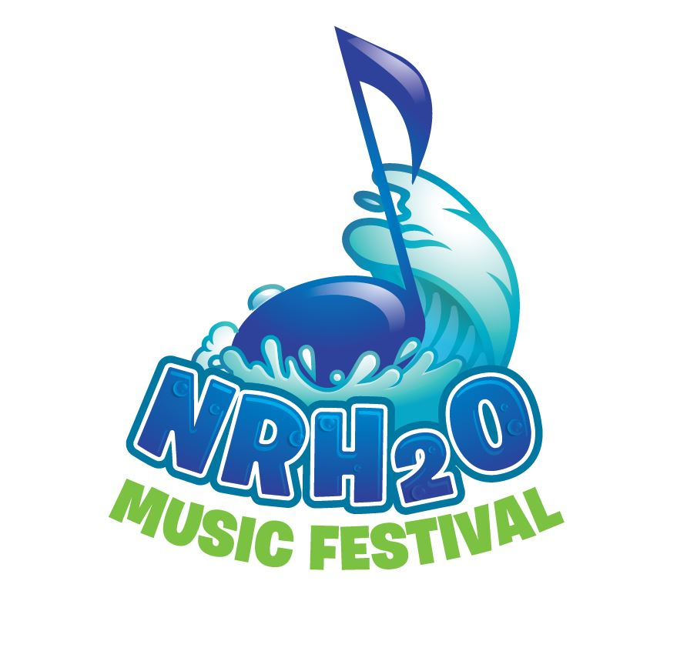
Please note this is the ONLY invoice you will receive. Request a check from your school/district for the maximum costs you could incur. A refund check will be provided to you on the day of the contest if you over pay. Make checks payable to NRH2O Music Festivals. We prefer teachers hand deliver the check on their day. In the event your school district requires mailing the final check, it MUST be in the mail by April 1. You will be notified once it is received.
Brad White Founder/Director: 