Invoice Date:_______________  Brad White Music Ed. Enterprises, LLC  Checks Payable to: NRH2O Music Festivals | Mail check to NEW ADDRESS: 2003 East Highway 114  Suite 340-1001  Trophy Club, Texas 76262  682-214-4920  Email: nrh2omusic@me.com  Website: www.nrh2omusic.com
If bringing multiple groups the deposit can be in one check however, do not combine checks with other schools or departments.
THE BELOW INFORMATION MUST BE FILLED IN
School Name:
Circle One: Band / Choir / Orchestra
Music Teacher
Performance Date(s):

$50 Deposit Per Ensemble due two months following registration before January 1, 2020. After January 1 $150
Your non-refundable deposit is applied towards your final invoice balance on the day you perform. Make checks payable to NRH2O Music Festivals.

Please include a copy of THIS INVOICE with each check!

 | Total Numbers | Price Per (each) | Total Dollars
Number of Performing Ensembles |  | X $50.00  X $150 (AFTER JAN 1)
Total Final Payment is due on the day of competition |  | Total Deposit Due

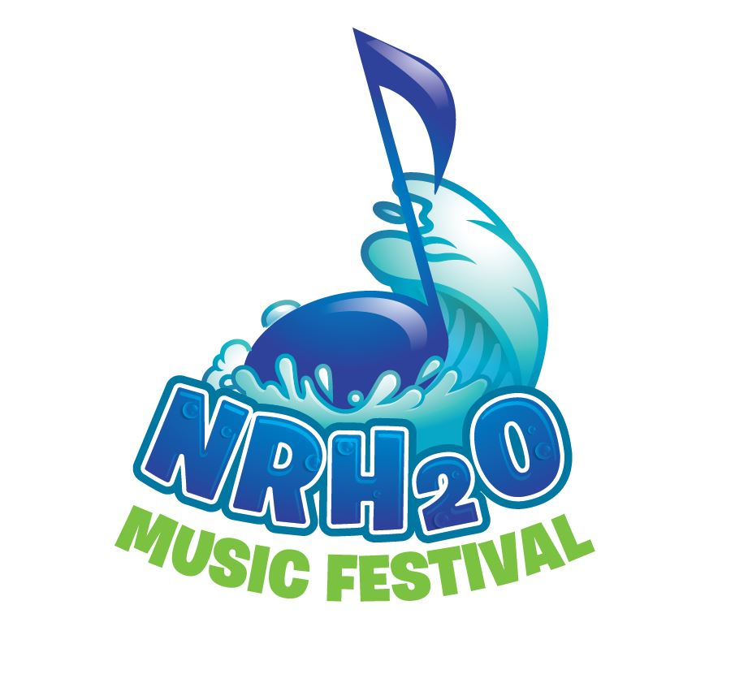

Brad White Founder/Director: 