Invoice Date:_______________  Brad White Music Ed. Enterprises, LLC  Checks Payable to: NRH2O Music Festivals | Mail check to NEW ADDRESS: 2003 East Highway 114  Suite 340-1001  Trophy Club, Texas 76262  682-214-4920  Email: nrh2omusic@me.com  Website: www.nrh2omusic.com
If bringing multiple groups the deposit can be in one check however, do not combine checks with other schools or departments.
School Name:
Circle One: Band / Choir / Orchestra
Music Teacher
Performance Date(s):

$50 Deposit Per Ensemble due two months following registration before January 1, 2019. $150 following January 1.

 | Total Numbers | Price Per (each) | Total Dollars
Number of Performing Ensembles |  | @ $50.00 or @ $150.00
Total Final Payment is due on the day of competition |  | Total Deposit Due
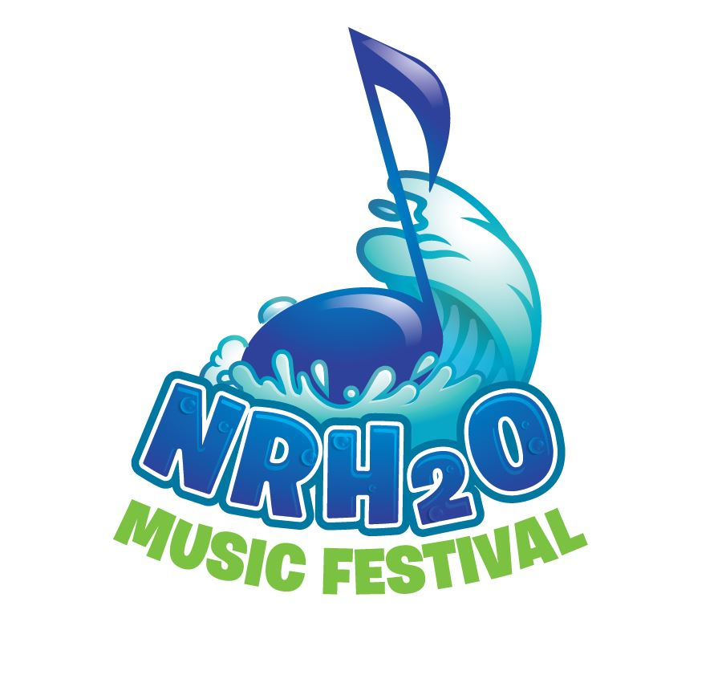
Your non-refundable deposit is applied towards your final invoice balance on the day you performance. Make checks payable to NRH2O Music Festivals.

Please include a copy of THIS INVOICE with each check!

Brad White Founder/Director: 