Invoice Date:_______________  Brad White Music Ed. Enterprises, LLC  Checks Payable to: NRH2O Music Festivals | Mail check to NEW ADDRESS: 2003 East Highway 114  Suite 340-1001  Trophy Club, Texas 76262  682-214-4920  Email: nrh2omusic@me.com  Website: www.nrh2omusic.com
Do not combine multiple schools, multiple days, or bands, choirs & orchestras from the same school with one check.
School Name:
Circle One: Band / Choir / Orchestra
Music Teacher:
Performance Date(s):

Deposit Per Ensemble is $50 before 1/1/18 or $150 after 1/1/18

 | Total Numbers | Price Per (each) | Total Dollars
Number of Performing Ensembles |  | @ $50.00 or @ $150.00
Total Final Payment is due on the day of competition |  | Total Deposit Due
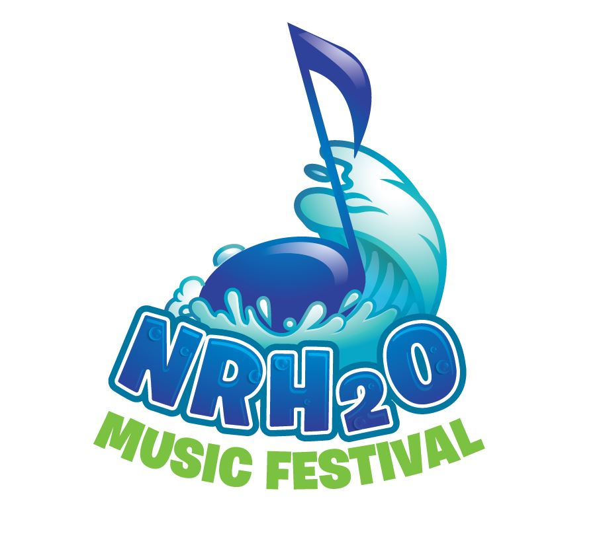 Director’s Signature:__________________________________________________________
Your non-refundable deposit is applied towards your final invoice balance on the day you performance. Make checks payable to NRH2O Music Festivals.

Please include a copy of THIS INVOICE with each check!

Brad White Founder/Director: 